10 "Little" Middle Ages

In an attempt to help you all understand the wide range of the "Middle Ages" in Europe, I have taken some inspiration from the essay of a famous author to break the Middle Ages into 10 "little" Middle Ages. This doesn't mean that each little Middle Age has a different time period; in fact, it is the opposite. Each of the little Middle Ages describes how modern-day historians, students, moviegoers, and everyday people view the time period between 500 AD and 1500 AD in Europe. In our class, we call it simply "The Middle Ages", but in reality, there are many different ways to view this time period, depending on the focus.
DARK AGE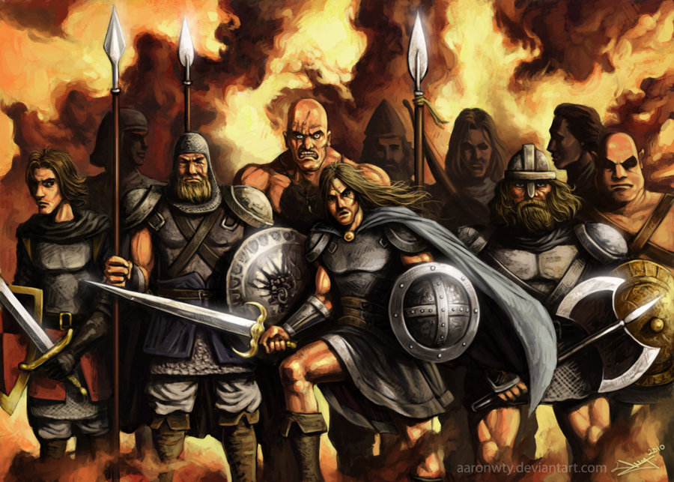
Dark Ages - Often, when people think of the Middle Ages in Europe, they think of a time period when barbarians constantly invaded the "civilized" territories, and a time when learning and progress were very limited.

FEUDALISM
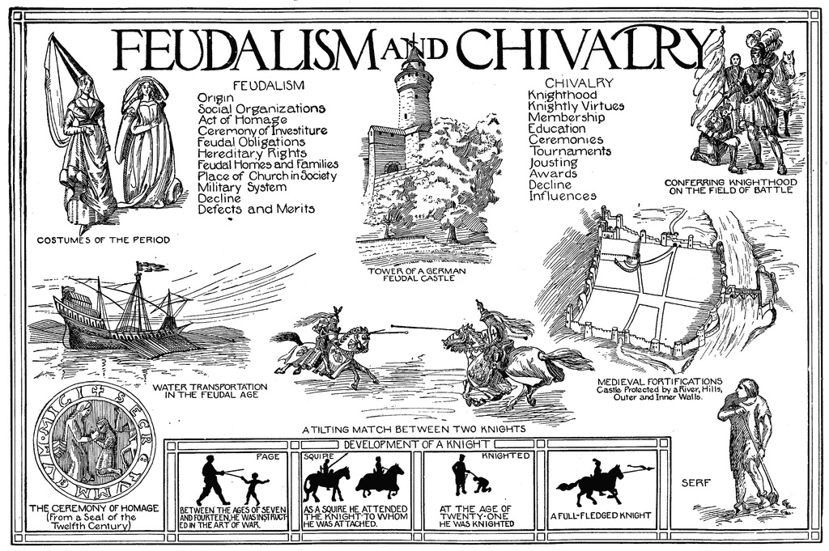
Feudalism - In many movies and books, the Middle Ages are usually represented by the feudal system, and its complex system of land ownership, vassalage, castles, fiefdoms, and kingdoms.

National Identity
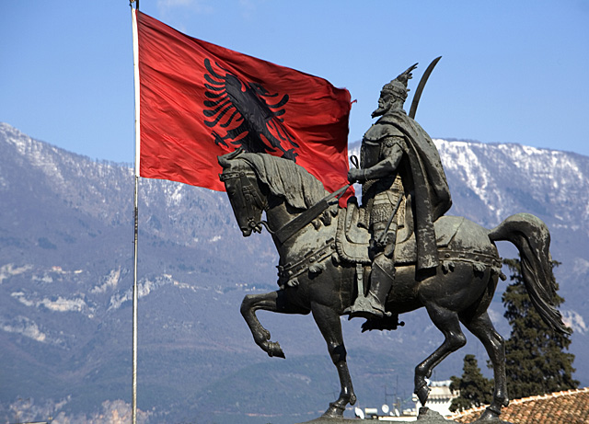
National Identity - In much the same way that Americans view Colonial America as the time when "America became American" (Paul Revere, George Washington, Pilgrims, etc.), Europeans view the Middle Ages as a time when their own national identity was formed. This was a time when the borders, traditions, and culture of many European countries were
forged.

Renaissance
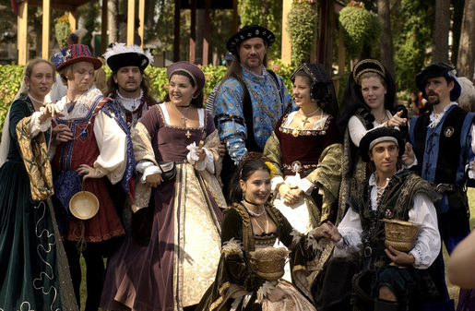

Renaissance - Even though the Renaissance signaled the end of the Middle Ages in its own way, technically speaking it was still well within the years that are commonly associated with the Middle Ages. Artists in particular look back on this era as a major shift away from some of the older, more traditional styles of the earlier Middle Ages. The Italian and Northern Renaissances will be discussed in depth in social studies class in the future.

Religious Philosophy
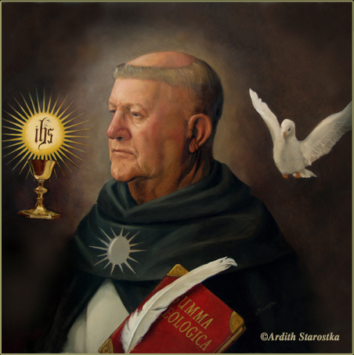
Religious Philosophy - Many people quickly identify the Middle Ages as a time when religion, in particular Roman Catholic Christianity, was at the peak of its influence. However, as time went on, religion evolved alongside other parts of medieval society.

Legends and Traditions
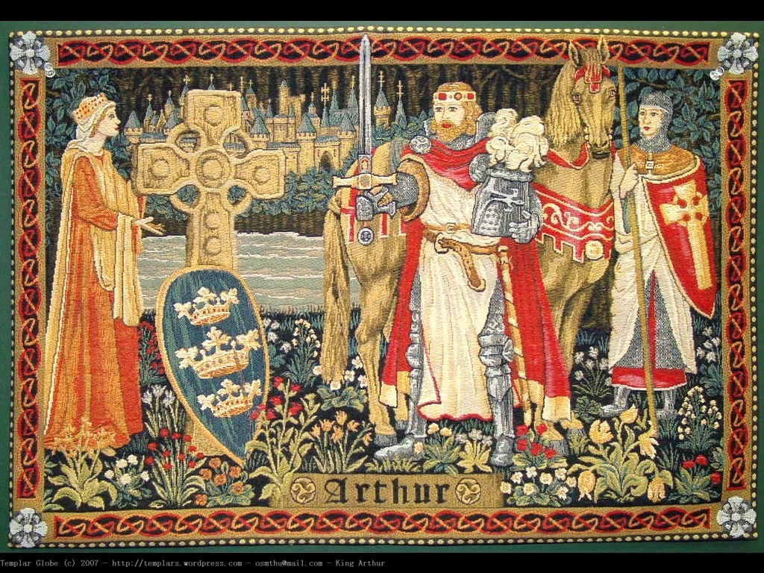
Legends and Traditions - The Middle Ages in Europe gave rise to many persistent myths, legends and traditions that are still recognizable today. These themes can range from religious topics (the search for the Holy Grail) to an exaggeration of a historical character (Robin Hood). During the Middle Ages themselves, a common pastime was storytelling, which made legends out of many characters and stories that are still well-known today.

Heroic Fantasy
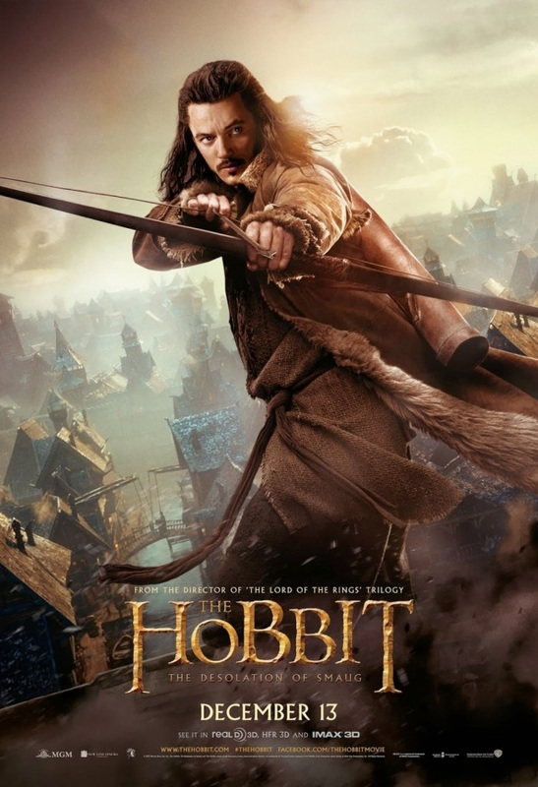
Heroic Fantasy - Interestingly enough, some people's views on the Middle Ages aren't influenced by historical events at all. Popular movies, games, and books are often set in a time period that reflects our perception of the European Middle Ages, even though they might be set in a fantasy world. These stories often feature medieval combat and weaponry, set in a land of kings ruling from their castle-like fortresses.

Medieval Philology
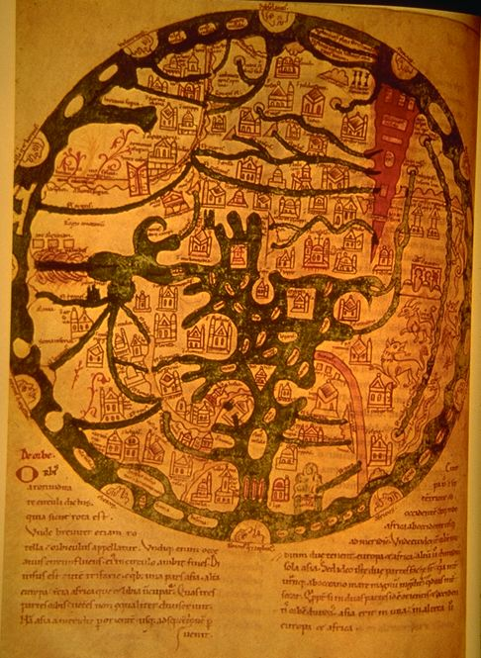
•
Definition of philology:
• 1. The branch of knowledge that deals with the structure, historical development, and relationships of a language or
languages.
• 2. Literary or classical scholarship.
• Medieval philology is the study of the time period by reconstructing the lives and events
of the Middle Ages by investigating what was written at that time. In the era of the internet, it has become much easier to share findings and translations from medieval sources.

Historical Background
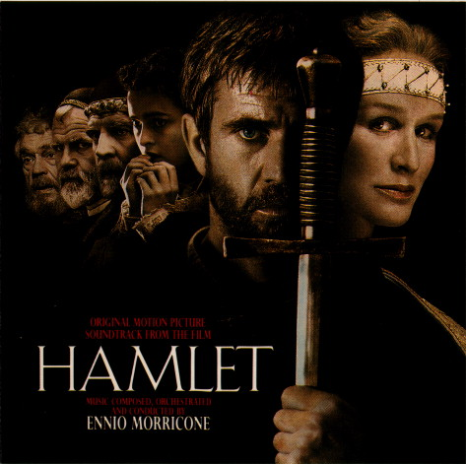
Historical Background - The Middle Ages were/are also often used as a backdrop or setting for stories meant to provide entertainment through the use of historical fiction. Famous authors and playwrights, such as Shakespeare used medieval settings to capture
the imagination of audiences. Often, the real focus of these stories have little to do with
the medieval setting, and instead are meant to portray human emotions and relationships from other eras.

End of Days
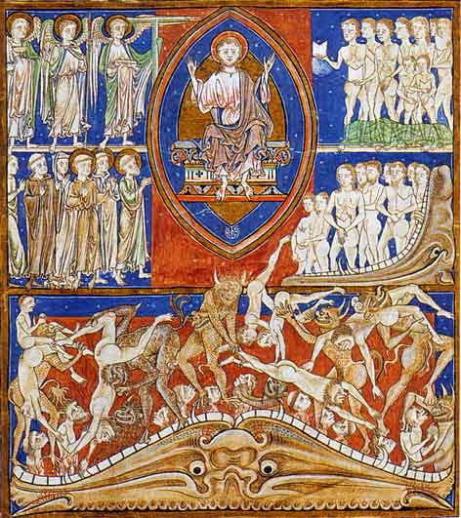
End of Days - One of the views of the Middle Ages is that it was a time period obsessed with Judgment Day. With every calamity seen as a harbinger of doom (such as the Black Plague), people in the Middle Ages were often reminded by artwork that final judgment awaited them.

