Name: __________________________________ Class: A B C F G
Contributions of Muslims to World Civilization
Baghdad
- What are two different “nick names” given to the capital Baghdad?
________________________________________________________________________________________________________________________________________________

- Who moved the capital to Baghdad? ________________________.

- How many workers did it take to build Baghdad, and how long? __________________________________________________________________.

- Describe the set up of the city ______________________________________________
________________________________________________________________________________________________________________________________________________
Mosque
- Give the name of the tower where the muezzin chanted the call to prayer _______________________________.
- What stood in the walled courtyard and what was it used for? _____________________________________________________________________
- What is the job of the imam ? ____________________________________________
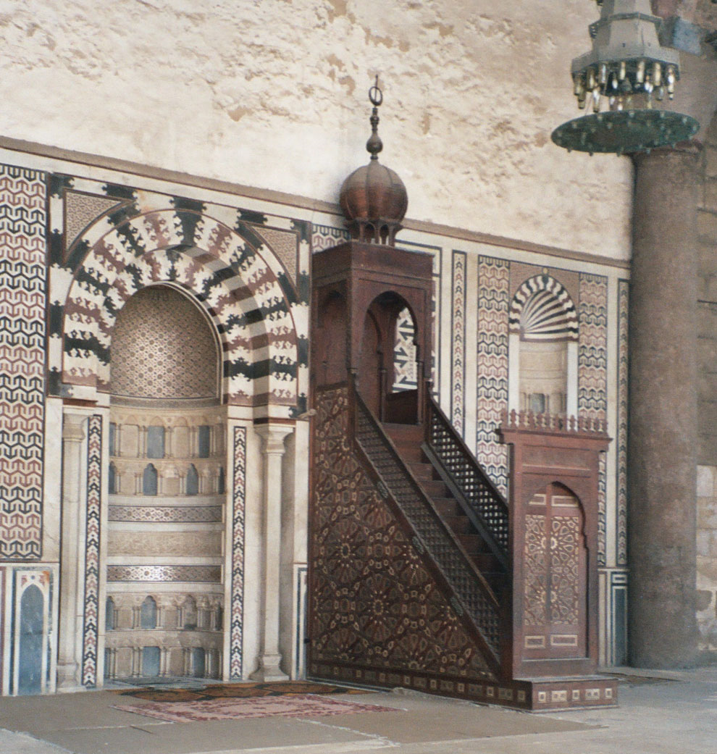
Minbar- _______________________________________________________________
Mihrab-_______________________________________________________________

- Are all mosques designed the same? Explain. _______________________________________________________________________________________________________________________________________________________________________________________________________________
Scholarship and Learning

- Write down Muhammad’s quote ____________________________________________________________________

- In the beginning of the 8th century what important role did the Arabic language play?
__________________________________________________________________________________________________________________________________________

- Muslim rulers built schools, colleges, and libraries below list the important buildings built in each city and give specific info on these important buildings:
Baghdad _____________________________________________________________
__________________________________________________________________________________________________________________________________________
Cairo ________________________________________________________________
__________________________________________________________________________________________________________________________________________
Cordoba _____________________________________________________________
_________________________________________________________________________________________________________________________________________

- What issue did Al-Kindi an Arab philosopher of the 9th century try to solve? _______________________________________________________________________________________________________________________________________________________________________________________________________________
- Describe Al-Kindi’s two sources of knowledge: ____________________________________________________________________________________________________________________________________________________________________________________________________________________________________________________________________________________
- Give the name of Islam’s most famous philosopher _________________________.

- What was his logical proof? _________________________________.

- Define immortal __________________________________________________________________________________________________________________________________________
Advances in Science and Technology

- What is Zoology? _____________________________________________________

- In what ways do you think science and technology changed how animals are cared for? __________________________________________________________________________________________________________________________________________
- Who is al-Jahiz and what is he known for? __________________________________________________________________________________________________________________________________________

- Below circle a legacy or “establishment” from the Muslim empire.

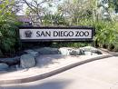

- What was the important use for astrolabes __________________________________________________________________________________________________________________________________________

- List the different important technological advances Muslims made and why these advances were important. _______________________________________________________________________________________________________________________________________________________________________________________________________________
- Define astronomy __________________________________________________________________________________________________________________________________________
- Define Evolution __________________________________________________________________________________________________________________________________________

Geography and Navagation

- What did the Muslims discover about the earth? _____________________________________________________________________
- Muslims were able to calculate what about the earth? Were they accurate? _____________________________________________________________________
- What did the work The Book of Roads and Provinces, contain? _______________________________________________________________________________________________________________________________________________________________________________________________________________
- What did the work The Book of Countries, contain? __________________________________________________________________________________________________________________________________________
_____________________________________________________________________
- Define circumference __________________________________________________________________________________________________________________________________________
Mathematics
- What important things for mathematics did scholars do in Baghdad’s House of Wisdom? __________________________________________________________________________________________________________________________________________
- Who is Al-Khwarizmi and what important things did he do? _______________________________________________________________________________________________________________________________________________________________________________________________________________
- Describe the importance of the Arabic numeral. ______________________________________________________________________________________________________________________________________________________________________________________________________________________________________________________________________________________________________________________________________________________________________________________________________________________________
- What important concept did Muslims help spread and where did this concept originate from? __________________________________________________________________________________________________________________________________________
Medicine

- Muslim doctors contributed to the field of medicine by establishing this and the FIRST OF ITS KIND!!! _________________________________________________________
- How did people pay for their medical expenses? __________________________________________________________________________________________________________________________________________
- Hospitals were in every city caravans brought people to these hospitals, caravans can be thought of as a modern form of which one of these pictures?

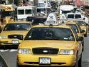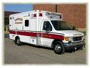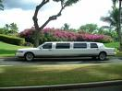

- How were hospitals divided up? ____________________________________________________________________________________________________________________________________________________________________________________________________________________________________________________________________________________
- What important roll did Pharmacists play? _______________________________________________________________________________________________________________________________________________________________________________________________________________
- What was al-Razi important discovery? __________________________________________________________________________________________________________________________________________
- What important thing did Ibn Sina do? What sort of impact did this work have? __________________________________________________________________________________________________________________________________________
- Define pharmacist- __________________________________________________________________________________________________________________________________________
- What did surgeons use to stitch up wounds? __________________________________________________________________________________________________________________________________________

Bookmaking and Literature

- Give the name of a famous collection of stories __________________________________________________________________________________________________________________________________________
- What is Sufism or Islamic mysticism? __________________________________________________________________________________________________________________________________________
- Who is Rumi and what did he do that was important? __________________________________________________________________________________________________________________________________________

Art and Music
- What makes Islamic art unique? _______________________________________________________________________________________________________________________________________________________________________________________________________________
- Define arabesque __________________________________________________________________________________________________________________________________________
- Define Calligraphy __________________________________________________________________________________________________________________________________________
- Why is calligraphy important? __________________________________________________________________________________________________________________________________________
- Where was calligraphy used? __________________________________________________________________________________________________________________________________________
- What important things could clothes represent? __________________________________________________________________________________________________________________________________________
- What sort of thing could be found on valuable cloths? __________________________________________________________________________________________________________________________________________
- What makes music in Cordoba so unique? __________________________________________________________________________________________________________________________________________
- Who is Zaria and what did he do that was important? _______________________________________________________________________________________________________________________________________________________________________________________________________________
- What is a conservatory __________________________________________________________________________________________________________________________________________
- In what city was Ziryab’s conservatory located? _____________________________________________________________________
- Name important instruments used in Islamic music __________________________________________________________________________________________________________________________________________

Recreation

- Where did Polo originate? __________________________________________________________________________________________________________________________________________
- Who usually played this sport and what was it nicknamed? __________________________________________________________________________________________________________________________________________
- When was chess introduced to Muslims? __________________________________________________________________________________________________________________________________________
- What is chess and who could play chess? __________________________________________________________________________________________________________________________________________

From this reading list all the important elements each city contained
Baghdad | Cordoba | Other (list the name of the different cities next to their contributions)

