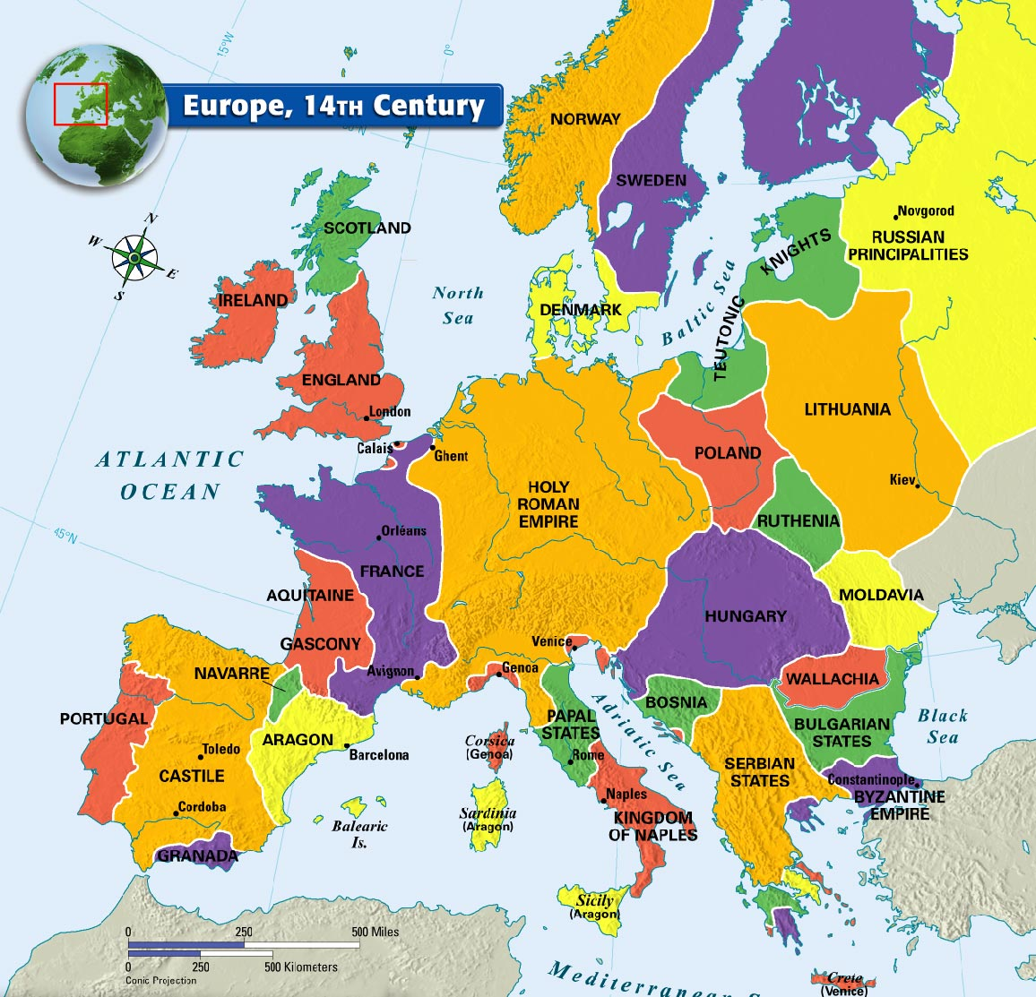
Norway Holy Roman Empire Atlantic Ocean Avignon
Sweden Papal States Mediterranean Sea
Denmark Kingdom of Naples Adriatic Sea
Scotland Venice Strait of Gibraltar
Ireland Sicily North Sea
England Byzantine Empire Baltic Sea
Granada
Portugal
Castile
Navarre
Aragon
Aquitaine
France
