Ancient China

Religion
Three major religions or philosophies shaped many of the ideas and history of Ancient China. They are called the three ways and include Taoism, Confucianism, and Buddhism.
Taoism
Taoism was founded during the Zhou Dynasty in the 6th century by Lao-Tzu. Lao-Tzu wrote down his beliefs and philosophy in a book called the Tao Te Ching.
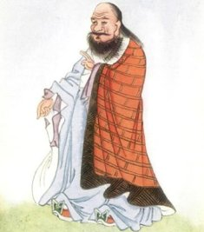
Lao-Tzu was the founder of Taoism
Taoism believes that people should be one with nature and that all living things have a universal force flowing through them. Taoists didn't believe in a lot of rules or government. In this way they were very different from the followers of Confucius.
The idea of Yin and Yang comes from Taoism. They believed that everything in nature has two balancing forces called Yin and Yang. These forces can be thought of as dark and light, cold and hot, male and female. These opposing forces are always equal and balanced.
Confucianism
Not long after Lao-Tzu founded Taoism, Confucius was born in 551 BC. Confucius was a philosopher and thinker. Confucius came up with ways that people should behave and live. He didn't write these down, but his followers did.
Confucius' teachings focus on treating others with respect, politeness, and fairness. He thought that honor and morality were important qualities. He also said that family was important and honoring one's relatives was required. Unlike Taoists, followers of Confucius believed in a strong organized government.
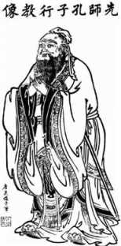
Confucius
Confucius is famous today for his many sayings. Here are a few of them:
- Forget injuries, never forget kindnesses.
- It does not matter how slowly you go so long as you do not stop.
- Our greatest glory is not in never falling, but in getting up every time we do.
- When anger rises, think of the consequences.
- Everything has its beauty but not everyone sees it.
Buddhism
Buddhism was based on the teachings of Buddha. Buddha was born in Nepal, just south of China, in 563 BC. Buddhism spread throughout much of India and China. Buddhists believe in a "rebirth" of the self. They also believe that the cycle of rebirth is complete once a person lives a proper life. At this point the person's soul would enter nirvana.
Buddhists also believe in a concept called Karma. Karma says that all actions have consequences. So actions you take today will come back in the future to help you (or hurt you) depending on whether your actions were good or bad.

Name: __________________________ Class: ________________________

Ancient China’s Religions Worksheet
- Which of the three religions is the oldest? __________________________

- Who started Taoism? ______________________________

- How is Taoism different from Confucius? ________________________________________________________________________________________________________________________________________________

- Can you draw the Yin and Yang symbol? If not try to draw a symbol you think demonstrates a balance of forces. Even if you know how to draw the Yin and Yang symbol you can also try to come up with your own symbol. We will share on the board.

- What did Confucius’ teachings focus on? ________________________________________________________________________________________________________________________________________________

- Who started Buddhism? __________________________

- What is Karma? _________________________________

- What is Nirvana? ________________________________________________________________________________________________________________________________________________

- Which one of Confucius’ sayings is your favorite, and why? ________________________________________________________________________________________________________________________________________________

- What is the difference between a philosophy and a religion? Are the above, religions or philosophies?

